Name :

Abubaker Attique

Roll num :

P20-0560

Section : 5-A

# Lab : 13

➔Implemen th S-NAT for web server of (fl an slat ) an Dynami -NAT for Clien System i singl topolog .(Us router an switche ).

**Topology:**

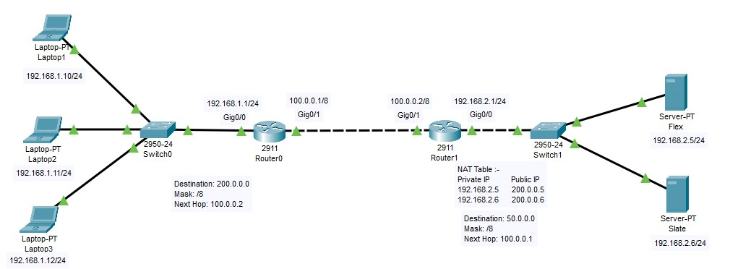

**PC configuration :**

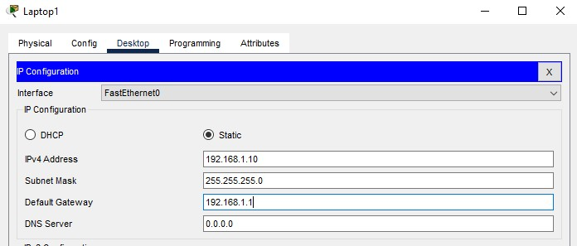

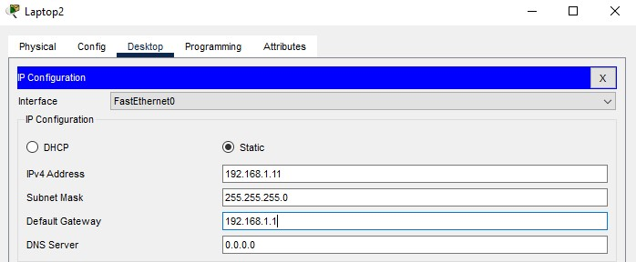

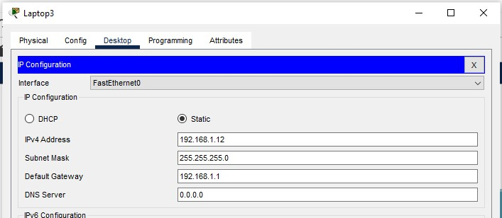

**Server Configuration :**

**Flex:**

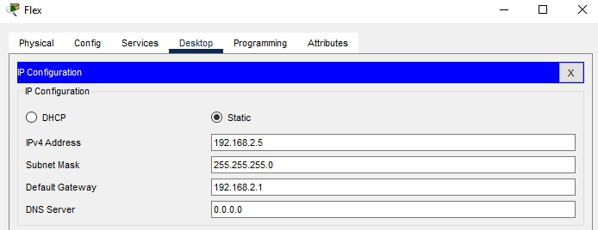

**Slate:**

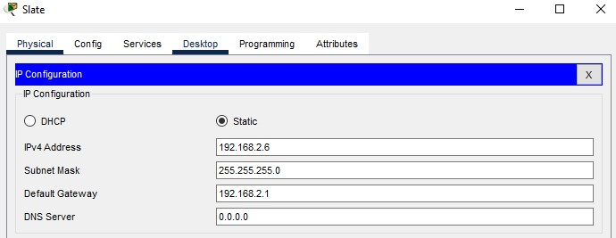

**Router Configuration :**

**Router0 :**

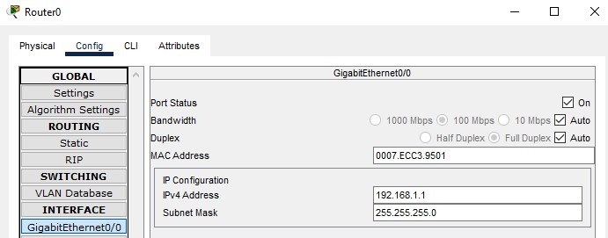

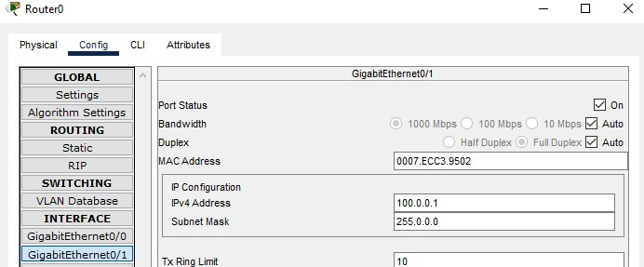

**Router1 :**

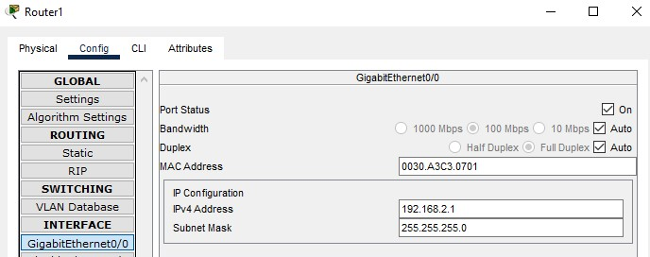

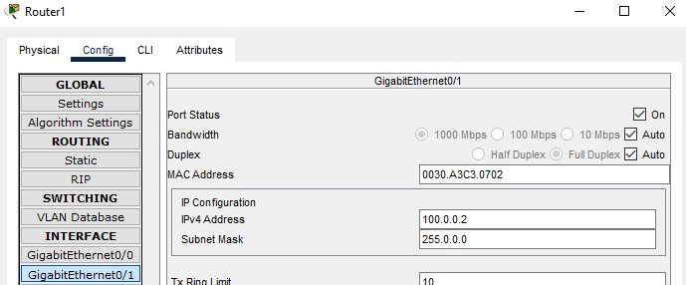

**Configure Dynamic NAT:**

**For Router0 :**

Dynamic NAT configuration requires four steps: -

1. **Create an access list of IP addresses which need translation:**

In this step we will create a standard access list which defines which inside local addresses are permitted to map with inside global address.

To create a standard numbered ACL following global configuration mode command is used:-

**Router(config)# access-list ACL_Identifier_number permit/deny matching-parameters**

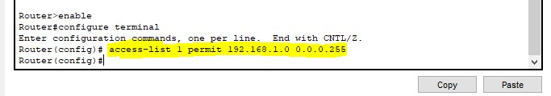

1. **Create a pool of all IP address which are available for translation:**

In the second step we define a pool of inside global addresses which are available for translation.

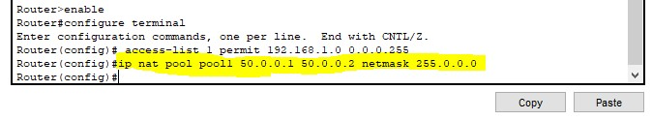

1. **Map access list with pool :**

In the third step we map access list with pool. Following command will map the access list with a pool and configure the dynamic NAT.

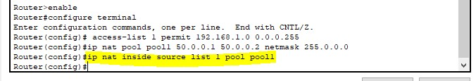

1. **Define inside global interface:**

In the fourth step we have to define which interface is connected with the global network and which interface is connected with the local interface .Following command will define interface Gig0/1 as inside global.



**Testing Dynamic NAT Configuration :**

To test this setup click Laptop 1 and Desktop and click Command Prompt.

* Run ping 200.0.0.5 command.

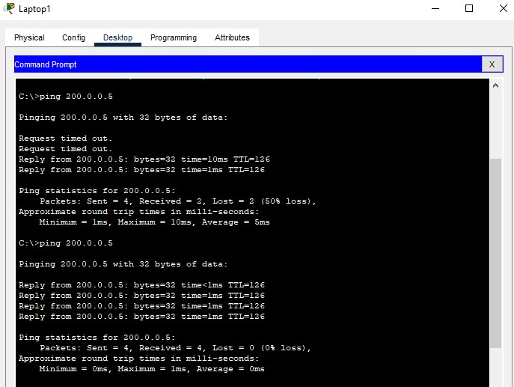

* Run ping 192.168.2.5 command.

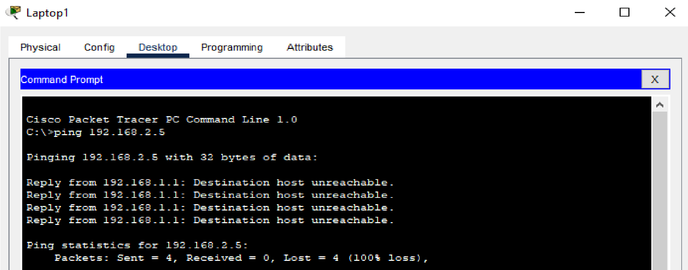

This Command gives the error “Destination Host Unreachable” because we are trying to access a remote device on its local IP address which is not possible because we can access remote devices only on their Public ip addresses.

**Creating File & putting it on Flex Server:**

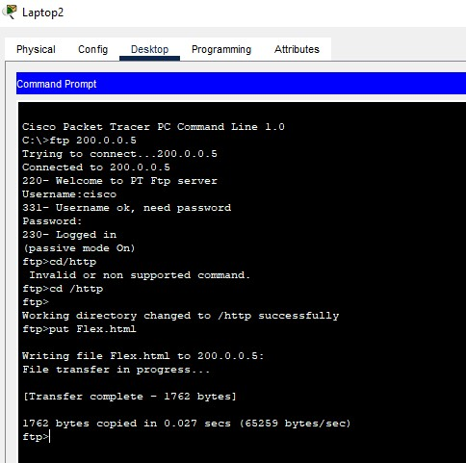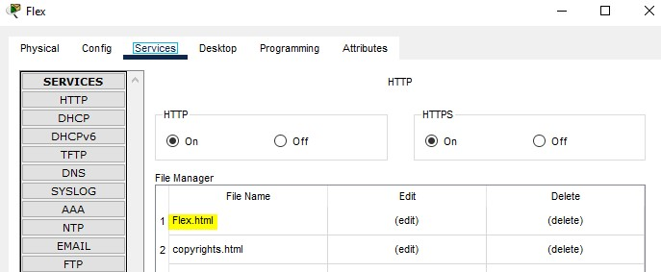

Doing the last testing. Click Laptop1 and click Desktop and click Web Browser and access 200.0.0.5.

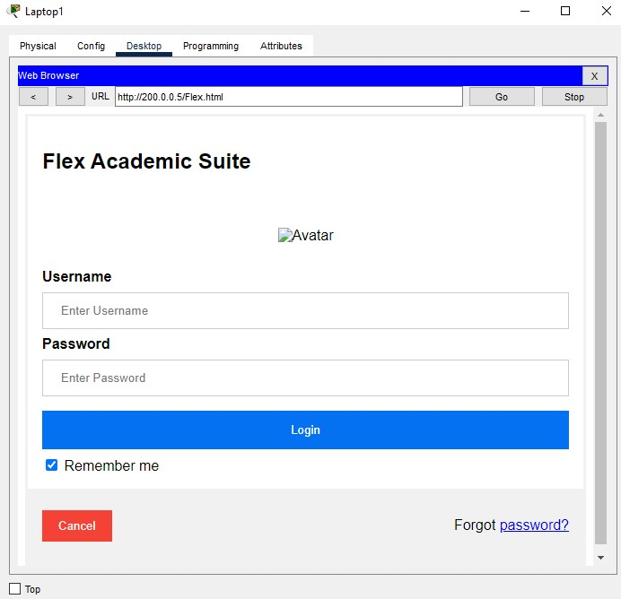

Above figure confirms that host 192.168.1.10 is able to access the 200.0.0.5.